For Immediate Release
Mayer Fabrics Celebrates Milestone 125th Anniversary

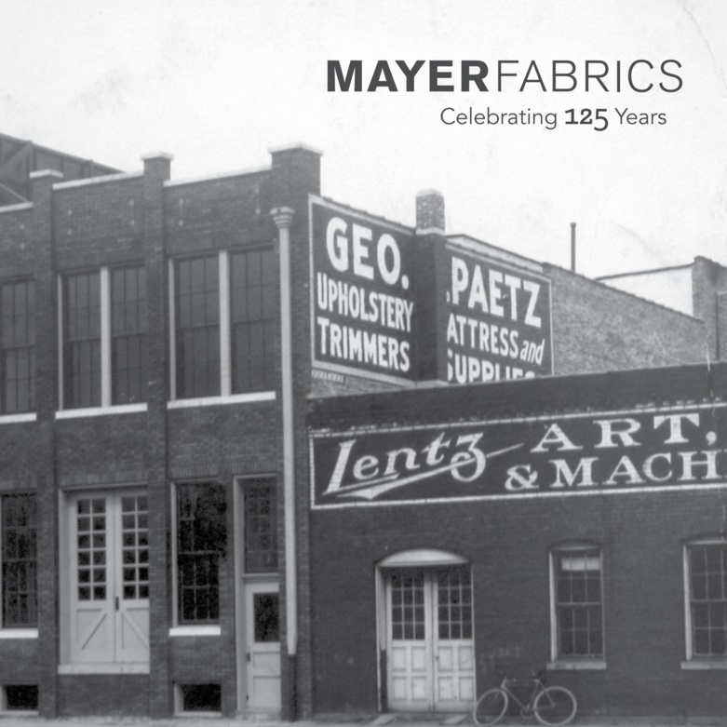
Indianapolis, IN – May 3, 2022.
Mayer Fabrics, a family-owned textile company serving the interior design community since 1897 is celebrating their 125th anniversary. Mayer Fabrics has a rich history that spans longer than most in its industry.
Beginning in 1897, George L. Paetz started the Paetz Company to fill a need for a local product supplier to manufacturers of custom designed buggies and repair. In the early 1900s, the company transitioned to a supplier of fabrics, vinyl, and upholstery for residential applications.

A new division of the Paetz Company, Mayer Fabrics, was created in 1988 to offer the contract market highly durable fabrics at price points that were previously unavailable. The success of the original offering led to dynamic partnerships with a select handful of mills and ultimately expansion into the hospitality and healthcare markets.

In January 2001, Mayer Fabrics acquired Lucia Cassa Textiles and the Lucia Cassa Convergence Collection marked a commitment to product attractiveness in both design and price. Mayer became one of the first UPS Carbon Neutral shipment companies in 2010 and by 2011, Mayer was a Carbon Neutral certified company. Most of Mayer Fabrics’ woven products became Greenguard certified in 2010, including panel fabrics, privacy curtains and seating upholstery. In 2020, to support material demand during the Covid-19 crisis, Mayer temporarily shifted product focus to PPE textiles.

“We could not have reached this milestone without everyone that has loved and supported our company in the past 125 years. It is humbling to have the 4th and 5th generations managing the business today”, said Rob Mayer, President & Co-Owner of Mayer Fabrics. “We believe those that have come before us would be proud of the company that has developed from the corner of a horse stable in August of 1897. Throughout this year we want to celebrate and thank everyone who has made Mayer the company it is today. To our associates, customers, partners, and anyone who has touched the Mayer brand, we thank you and we look forward to what lies ahead.”

Today Mayer Fabrics’ operations spans the U.S, Canada, Mexico, and internationally. Their corporate headquarters, located in Indianapolis, IN acts as their main distribution point for products and office personnel. As their product offerings have grown so has their passion for the industry and the commitment to its customers and employees.

“Not a week goes by that a customer doesn’t say to me, you have exceeded my expectations more than anyone else has ever done”, stated Jen Fallis, Mayer’s Sales Service Manager. “And I always say, that’s what we do, that’s what we do at Mayer Fabrics. And it’s true. It’s what we have done for 125 years and it’s what we will continue to do for the next 125 years.”

For more information on Mayer Fabrics and their products please visit mayerfabrics.com.

For Additional Information Contact:
Social Media (@MayerFabrics)
Instagram
Facebook
Pinterest
LinkedIn
YouTube
Vimeo

Jessica Rangel
Marketing Director
Mayer Fabrics
TF 800.428.4415
D 219.274.3630
jessica.rangel@mayerfabrics.com

Showroom Locations Atlanta | Chicago | New York | San Francisco

