8/3/2022

About Crypton & Crypton Home Fabrics & 100% Fluorine-Free Performance

By October 1, 2022 all new production runs of Crypton and Crypton Home Fabrics will be manufactured using our PFAS free technology.

Here’s what you can count on:

State-of-the-art Performance Fabric.
- 0% fluorine, tested and verified in accordance with test method AATCC189
- Engineered to repel and resist water-based liquids and stains
- Stays beautiful and fresh with silver-ion technology (Crypton Home or when specified)
- Maximum durability and abrasion resistance
- Soft, beautiful and perfectly suited for everyday living
- Unmatched cleanability
- Crypton contract fabrics with our moisture barrier remain EPA disinfectable

Experience.
Our PFAS free technology has been painstakingly researched & optimized by Crypton scientists over more than five years, employing:

Sustainable Chemistry & Physics
    - Hydrocarbon Side Chains are added to create repellency, mimicking the natural repellency and self-cleaning ability of leaves (biomimicry).
    - Partially sourced from renewable resources. (Around 40% content from renewable resources)
    - Achieving high-level fluorine-free performance required not only optimizing chemistry but also utilizing physics to create highly effective and permanent performance characteristics
    - Permanent protection sealed into every fiber for the life of the fabric using the same patented process that Crypton & Nanotex perfected
    - The meticulously balanced formulation ensures maximum durability and unmatched cleanability
    - Zero halogenated content (Fluorine, Bromine, Chlorine)
    - Formaldehyde-free
    - The highest possible standard of fluorine-free performance

Certainty.
Our proprietary fluorine-free technology is:
- Made in our own North Carolina facilities for quality assurance & control
- GREENGUARD Gold certified
- 2-Year Warranty for Crypton Home Fabric, 5-Year Warranty for Crypton Fabric

Transparency.
We have always been and will continue to be transparent about our products and are committed to ongoing innovation. If you have any questions, please contact your Crypton representative.

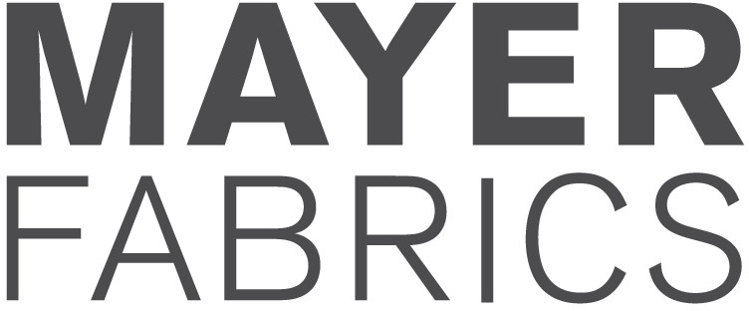
mayerfabrics.com 800.428.4415

